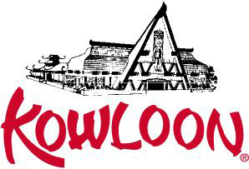

Luncheon Menu

*Kowloon Luncheon*

Served Family Style Lunch in our Main Dining Room

Offer Monday through Friday 11:30 AM to 4:30 PM
For Party of 10 or more (subject to availability)

Appetizer and Soup
Egg Rolls, Spring Rolls, Crab Rangoon, Peking Ravioli, Hot & Sour Soup,
Chicken Fingers, Scallion Pie, Vegetable Ravioli, Fried Crispy Wonton

Main Course
Chicken and Broccoli, Kung Pao Chicken, Beef and Broccoli, Moo Goo Guy Pan, Vegetable Delight,
Vegetable or Roast Pork Egg Foo Yung, Sweet & Sour Chicken, Lobster Sauce, General Gau Chicken
Roast Pork Fried Rice, Vegetable Fried Rice, Steamed White Rice, Pork Lo Mein
Vegetable Lo Mein, Pan Fried Soft Noodles, Subgum Chow Mein

Selection of Five $17.35 per person
Selection of Six $20.30 per person
Selection of Seven $23.05 per person

**Also available Buffet Style for Party of 35 or More**

**All prices subject to 7% Saugus Meals Tax and 18% additional charge**

***All Pricing are subject to change

Phone 781.233.0077, fax: 781.231.5475 948 Broadway (Rt 1 North) Saugus, MA 01906, Kowloonfunction@gmail.com

01/20

